Kenneth Cluck  
07/08/2023  
CS-330 Module Two Milestone

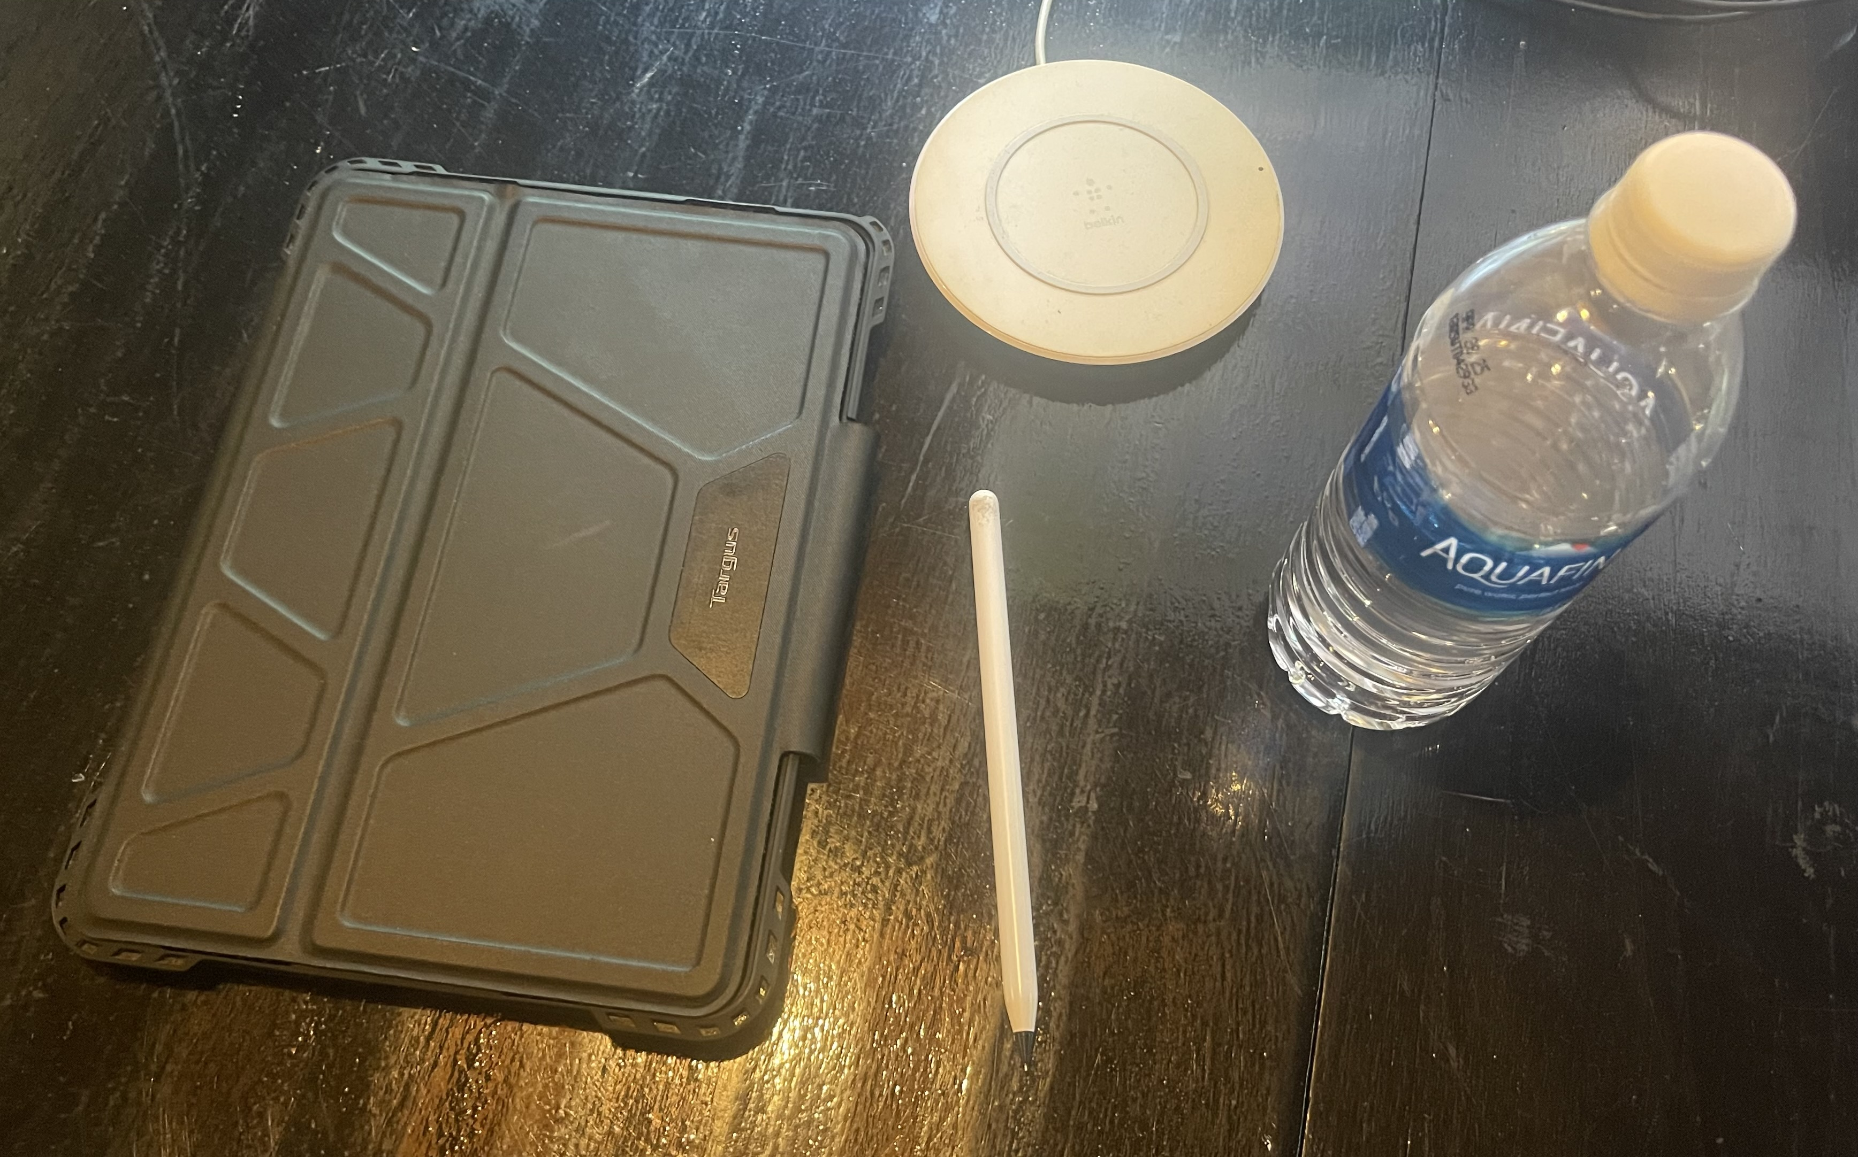

The scene that I have chosen is some random objects on top of my desktop. There are a few primitive shapes that could be incorporated to recreate this scene. First the desk itself would be a plane. I do not feel I need to include the lines in the desk as that is an extra detail. For clarity it also might be a good idea for this to be colored differently or at minimum a distinguishable shade from the ipad, which would be created with cube object that is stretched out and flattened. The apple pencil would be a long cylinder. The charging pad would also be a cylinder but would be shorter. The water bottle would consist of multiple objects. The base of the water bottle would be one cylinder, while the top could other be a many-sided pyramid or a cylinder that comes to an end, in a conic shape. These items have sufficiently low required detail to distinguish them. These items should be simple to replicate in a 3d scene.